**Test Document for Control Tower Update Missed for Some Dates of Past**

Before Update Session Run :-

Actual Percentage for Project JB1013 at 06-12-2018 is 0.00

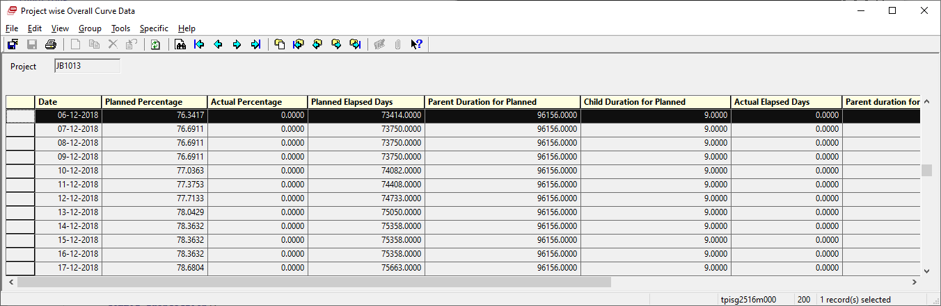

Actual Percentage for Project JB1014 at 06-12-2018 is 0.00

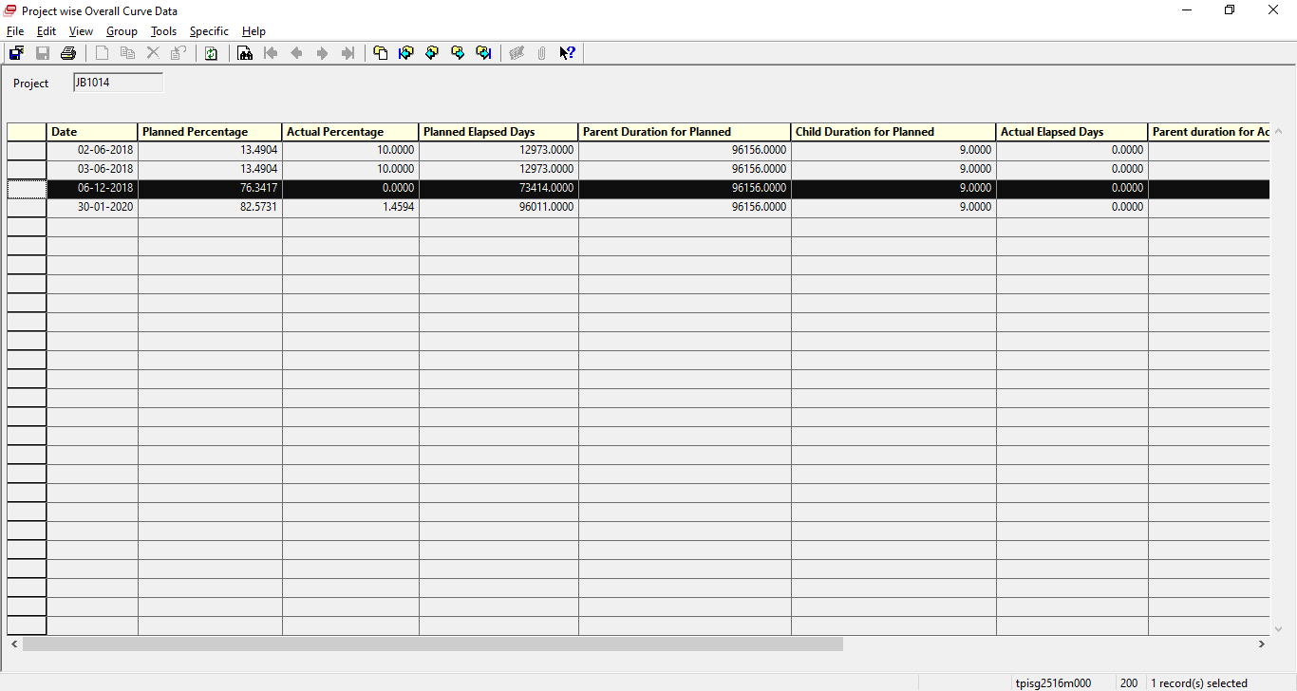

After Update from Session tpisg2216m000,

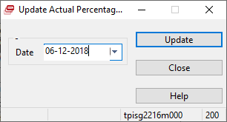

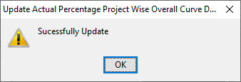

Data are:

For JB1013 :

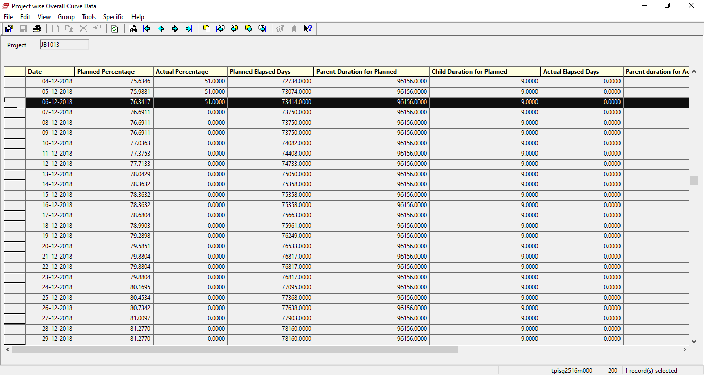

For JB1014 :

